# Exercise 2

It is the time to open up the black-boxes without imposing too much constraints on the implementation details. Let's modify the solution so that it would log important events in the following format:

* Log entries are in JSON, one JSON object per line
* Optional text comments could start with the #, they are ignored.

We need to **log an entry when the important domain events happen: transport departs and when it arrives**.   
A single line in the log might look like the one below. It is pretty-printed to look nice, normally it would be **one line**:

{  
 "event": "DEPART", # type of log entry: DEPART or ARRIVE  
 "time": 0, # time in hours  
 "transport_id": 0, # unique transport id  
 "kind": "TRUCK", # transport kind  
 "location": "FACTORY", # current location  
 "destination": "PORT", # destination (only for DEPART events)  
 "cargo": [ # array of cargo being carried  
 {  
 "cargo_id": 0, # unique cargo id  
 "destination": "A",# where should the cargo be delivered  
 "origin": "FACTORY"# where it is originally from  
 }  
 ]  
}

Given that file, we could do two things with our event logs:

1. Compare the reasoning of our solution to the reasoning from the another solution (even though they could be in different languages).
2. Feed it to the <https://github.com/Softwarepark/exercises/tree/master/transport-tycoon/trace/> script that will convert this log to Chrome Trace Viewer format file (also JSON, but a different format).   
   That file could be loaded in Chrome to display the outline of our travel.

Here is an example event log for the entire AB delivery:

# Deliver AB  
{"event": "DEPART", "time": 0, "transport_id": 0, "kind": "TRUCK", "location": "FACTORY", "destination": "PORT", "cargo": [{"cargo_id": 0, "destination": "A", "origin": "FACTORY"}]}  
{"event": "DEPART", "time": 0, "transport_id": 1, "kind": "TRUCK", "location": "FACTORY", "destination": "B", "cargo": [{"cargo_id": 1, "destination": "B", "origin": "FACTORY"}]}  
{"event": "ARRIVE", "time": 1, "transport_id": 0, "kind": "TRUCK", "location": "PORT", "cargo": [{"cargo_id": 0, "destination": "A", "origin": "FACTORY"}]}  
{"event": "DEPART", "time": 1, "transport_id": 0, "kind": "TRUCK", "location": "PORT", "destination": "FACTORY"} {"event": "DEPART", "time": 1, "transport_id": 2, "kind": "SHIP", "location": "PORT", "destination": "A", "cargo": [{"cargo_id": 0, "destination": "A", "origin": "FACTORY"}]}  
{"event": "ARRIVE", "time": 2, "transport_id": 0, "kind": "TRUCK", "location": "FACTORY"}  
{"event": "ARRIVE", "time": 5, "transport_id": 1, "kind": "TRUCK", "location": "B", "cargo": [{"cargo_id": 1, "destination": "B", "origin": "FACTORY"}]}  
{"event": "DEPART", "time": 5, "transport_id": 1, "kind": "TRUCK", "location": "B", "destination": "FACTORY"} {"event": "ARRIVE", "time": 5, "transport_id": 2, "kind": "SHIP", "location": "A", "cargo": [{"cargo_id": 0, "destination": "A", "origin": "FACTORY"}]}  
{"event": "DEPART", "time": 5, "transport_id": 2, "kind": "SHIP", "location": "A", "destination": "PORT"}

## Task

* **Extend your solution** to print domain events.
* Run the domain event log through the trace.py converter and then **display in the Chrome Trace tool**.  
  Does the AABABBAB solution look right? Does it complete on the hour 29? What about ABBBABAAABBB?
* Add a new rules to the code:
  + **Ship can take up to 4 containers, but is slower now**:
  + Ship takes 1 hour to load *all* cargo
  + Ship takes 1 hour to unload *all* cargo
  + Ship takes 6 hours to travel in each direction
  + Note, that ship doesn't wait to be full in order to DEPART. It just LOADs the available cargo and leaves.
* Add LOAD and UNLOAD events to the domain output. They have similar schema as ARRIVE, are published at the beginning of the operation and have duration field (0 for TRUCK and 1 for the SHIP)

## Reference Traces

We are including reference traces so that you could compare your simulation results.

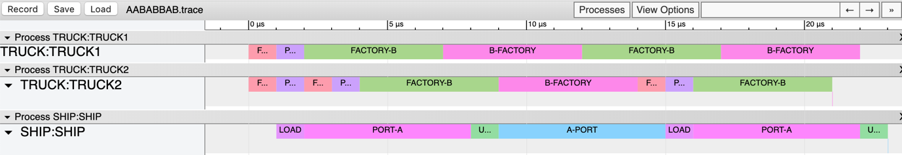*AABABBAB*

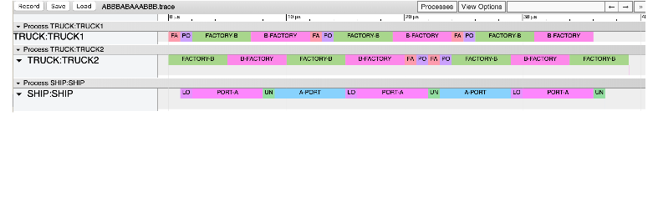*ABBBABAAABBB*

## Exercise Notes

* Feel free to add domain logs and rendered trace files alongside your solution and **point to their folder** in the solution list <https://github.com/Softwarepark/exercises/blob/master/transport-tycoon/README.>md ("*Ex 2*" column). For example, put domain logs for the AB scenario into AB.log.  
  Solution list already has some references.
* Check out the exercise discussions at <https://github.com/orgs/ddd-exercises/teams/tt/discussions>